**Practical No: 6**

**Study Cloud Security management.**

1. Login to owncloud.

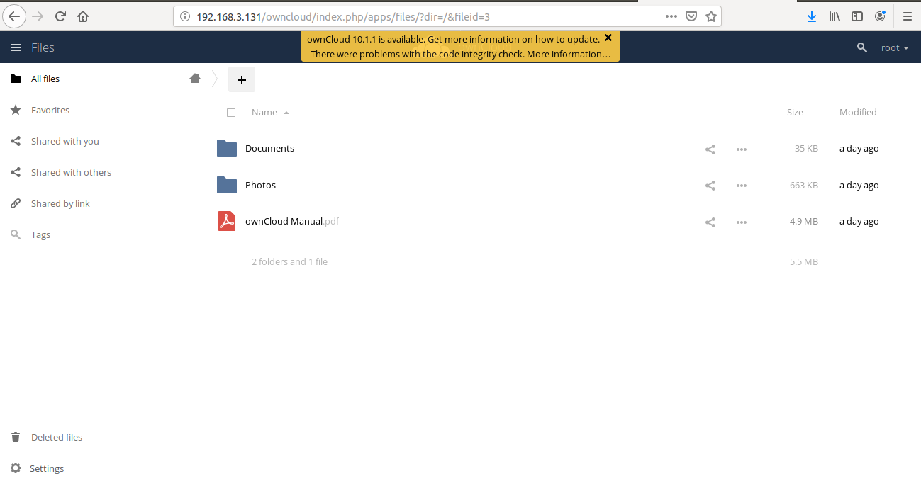

2. Go to Admin>>Settings.

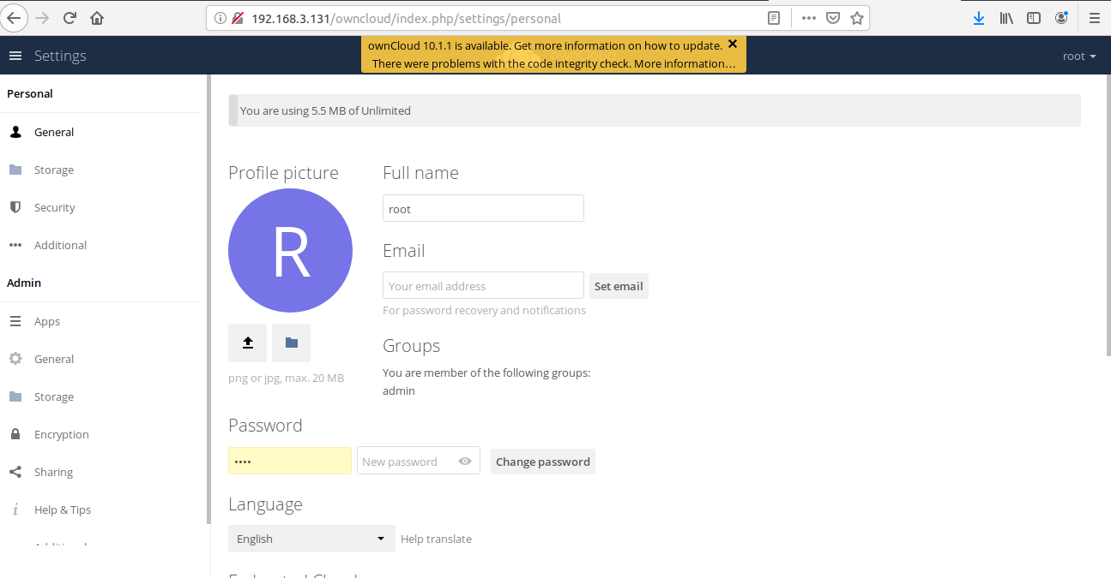

3. Go to Apps and click on Show disabled apps.

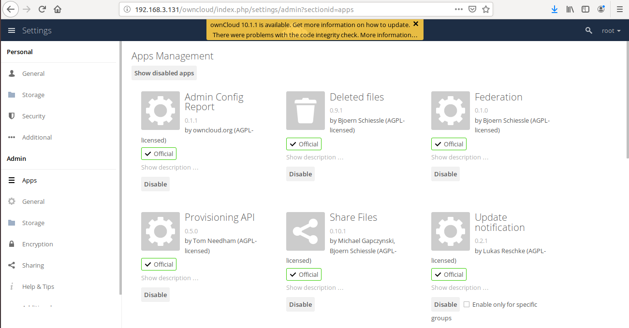

4. Enable Default Encryption Module.

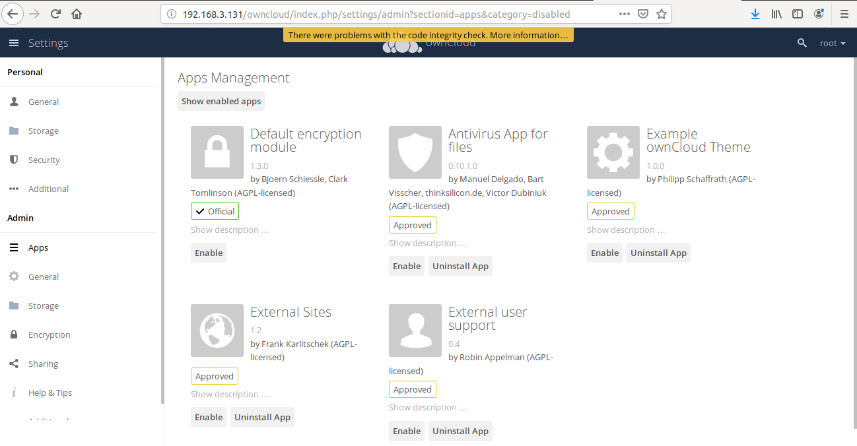

5. Go to Encryption and click checkbox Enable Sever side Encryption.

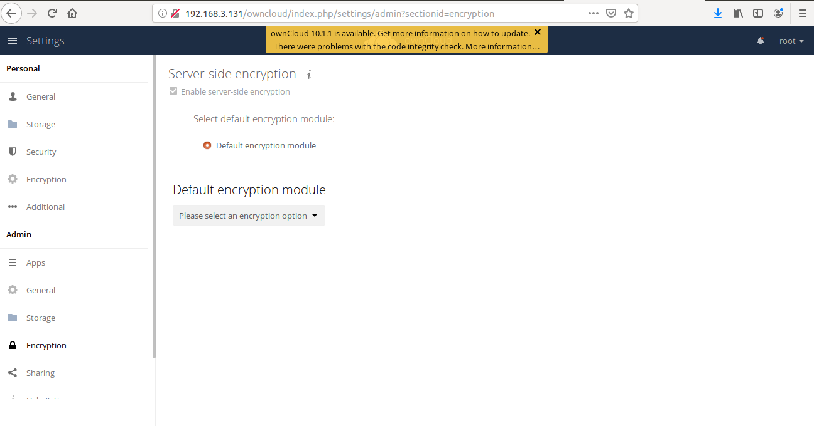

6. Log out and log in again to affect changes.

